|  |  |  |
| --- | --- | --- |
| **FOCUS**  **Volume 39, No. 6**  **March 2013**  **Fairfax City (VA) Branch** | | **FOCUS**  **Volume 39, No. 6**  **March 2013**  **Fairfax City (VA) Branch** |
| **FOCUS**  **Volume 39, No. 6**  **March 2013**  **Fairfax City (VA) Branch** | |
| **FOCUS**  **Volume 39, No. 6**  **March 2013**  **Fairfax City (VA) Branch** | **FOCUS**  **Volume 39, No. 6**  **March 2013**  **Fairfax City (VA) Branch** |

**The Invisible War  
Thursday, March 28, 4:30 p.m.  
Johnson Center Cinema  
George Mason University**

**Northern District News**

By Sandy Lawrence  
Northern District Representative

Still haven’t seen *The Invisible War*? Want family, friends, and neighbors to see it?

Here’s your chance. George Mason University and AAUW are teaming to screen *The Invisible War* on Thursday, March 28, from 4:30 to 7 p.m. at George Mason University Fairfax campus, Johnson Center Cinema. This screening is free and open to the public.

There will be a panel discussion after the movie. Holly Kearl, AAUW Legal Advocacy Fund Program Manager, and Sandy Lawrence will be on the panel. We have also asked Attorney Susan Burke or her representative to participate.



Prior to and after the movie, there will be tables in the foyer for AAUW literature and laptops connected to the AAUW site so students can get an e-student affiliation membership. There will also be movie favorite snacks.

How can you help? Branch members are needed to man the tables to answer questions about AAUW, provide information about AAUW activities at all levels, and take names of potential new branch members. We need members to get the word out to their community and other organizations about the event. Of course, a bag of movie snacks is always welcome. Please tell your branch president how you can help.

The Johnson Center Cinema is located on the lower (ground) floor of the Johnson Center, which is near the statue of George Mason. Public parking is available in the Mason Pond Parking Deck. Parking rates are $3 an hour.

**In this issue**:

Membership 2  
Trafficking 2  
Turning Point 2  
The Heart Truth 3  
EveryOne Counts 3  
Tributes 4  
Calendar 5  
Interest Groups 6

**Membership Memo**By Dottie Joslin

**Membership Bargains for New Members**Share your enthusiasm for AAUW and ask a friend to join our branch. Until March 15, members new to AAUW or lapsed for two or more years can join the Fairfax City Branch by paying half-year dues ($41) for membership through June 30, 2013. After March 15 full-year dues for 2013-2014 are in effect, up to 15 months of membership for one year’s dues ($82). If a new member joins at a branch meeting, an additional Shape the Future discount is available.

**Do You Know a Graduate Student?**  
In celebration of AAUW’s founding in 1881, AAUW is offering a special introductory rate for new graduate student members who join by June 30, 2013. Dues are only $18.81 for one year of National Membership. Give a graduate student an AAUW membership, or tell her or him about this bargain! State and local dues are extra. Visit www.aauw.org for an online membership application.

**Trafficking of Girls**

At our January 26 branch meeting, George Mason professor Rita Chi-Ying Chung talked about her work in cross-cultural and multicultural psychology and counseling, especially as it affects girls who are victims of trafficking. Dr. Chung explained her work in Myanmar (Burma) as a consultant and trainer for Save the Children Alliance on child protection, human trafficking, post-disaster counseling and vulnerable children and orphans.

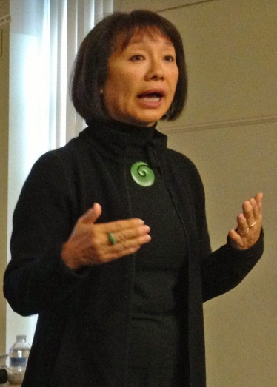

Rita Chi-Ying Chung

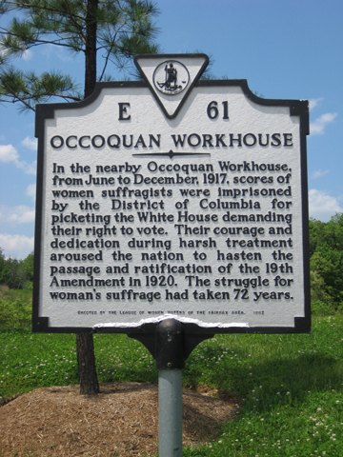Several members asked for the names of the organizations working to combat child trafficking that she mentioned in her video presentation. Dr. Chung said they included Polaris Project, National Center for Missing & Exploited Children, StreetlightUSA, and RAINN (Rape, Abuse & Incest National Network).

**Turning Point**By Anita Aymer  
AAUW of Virginia VP for Programs

The Turning Point Suffragist Memorial, to be located in Occoquan Regional Park, will honor the lives of the suffragists who fought for the ratification of the 19th Amendment. Individuals and organizations who donate $1,000 or more will have their names placed on a wall of honor at the site of the memorial. AAUW of Virginia is asking every branch member to donate a $1 towards this effort so that our support of the Suffragist Memorial can be acknowledged.

Our goal for AAUW of Virginia is to collect $1,000 plus and be listed on the wall of “Friends” for supporting the memorial. Our deadline for contributions is April 13 and our grand total will be announced at the state conference. Be sure to include your AAUW branch name on the check on the memo line so AAUW will receive full credit for contributions.

Thank YOU for appreciating the sacrifice of the suffragists and others who gave so much for our rights as women.

Send a check to the following:  
 TPSM Association  
 PO Box 502, Occoquan, VA 22125   
Or donate at their website:  
<http://www.suffragistmemorial.org/>

***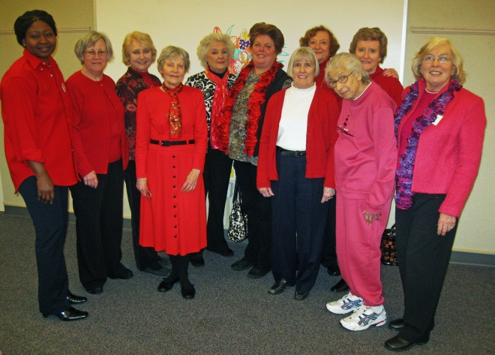*The Heart Truth®**

Members came to the February 23 branch meeting wearing red to acknowledge that February is Women’s Heart Month. Our speaker, Gabby Awosika, Heart Disease Survivor and WomenHeart Champion, represented the National Coalition for Women with Heart Disease. Emphasizing that heart disease is the leading killer of women in America; she explained what heart disease is and how to recognize its signs and symptoms. After listing the factors that increase the risk of heart disease, she pointed out how women can lower that risk. Gabby left a bag of information for each of us so we could learn how to be smart about our heart.

**Notice Anything New?**By Leslie Vandivere

AAUW’s new logo graces the heading of this issue of the *Focus*. AAUW’s first new logo in 20 years features a bold, bright palette and a strong, descriptive tagline that celebrates AAUW’s history. Along with the new logo is a new AAUW website, which offers increased social media integration, mobile access, and a host of other user-friendly updates. Go to [www.aauw.org/](http://www.aauw.org/) and have a look around!

While you’re looking, check out the new AAUW of Virginia website at <http://aauw-va.aauw.net>. Comments about the website are welcome. What do you find useful and what isn’t useful? What else would you like to see on the website? Send your comments to the webmaster at [lvandivere@cox.net](mailto:lvandivere@cox.net).

**Celebrate EveryONE Counts**

Couldn’t be a better place to be the second weekend in April than Richmond! Our one-day statewide meeting, EveryONE Counts, celebrates the fact that AAUW of Virginia has been using the One Member, One Vote for a year now, with great success!

The conference will take place at the new Holiday Inn Richmond Airport in Sandston, just a mile from the Richmond Airport, easily accessible for conference attendees. Greater Richmond AAUW looks forward to having you all back to Richmond for an engaging and busy meeting. Register before April 1 and pay just $45!

The conference begins at 10:30 a.m. on Saturday with a buffet brunch, included in the registration fee. Our keynote speaker is Karen Remley, the former state commissioner of health, who resigned in protest over the stringent new requirements for abortion clinics. Her address will be followed by the annual business meeting and a town hall discussion by AAUW Vice President Patricia Fae Ho.

The busy day continues with district meetings followed by a choice of enlightening workshops: *Count Us IN: Become a Website Wonder*, led by Patsy Quick, Leslie Vandivere, and Megan Morrison; *Skinning the Cat: Many Ways to Lead*, led by Patricia Fae Ho and Caroline Pickens, and *Creating and Innovating the Best Membership Practices: What Can We Learn From Others?* led by Mary Beth Pelosky and Sally Sledge.

If you decide to come Friday evening, we will all gather in the Hospitality Suite with the state board members from 7 to 10 p.m. to relax and enjoy each other’s company, wearing our college shirts to remember bright college days.

You can register for the conference in one of the following ways.

Download and mail the registration form found at the state website at <http://aauw-va.aauw.net/files/2012/12/2013brochu_reg.pdf> or mail in the form found in the Winter/Spring issue of the *Vision* or the conference brochure.

Join us and become energized for spring. Learn about websites, leadership, and membership at the workshops. Catch up with friends from around the state. Meet Patricia Fae Ho, national AAUW vice president.

**Tributes to Sylvia Castelnovo**

**By Dottie Joslin.** Sylvia Castelnovo, a Fairfax City Branch member since 1980, passed away on January 30, 2013, at the age of 86. Many of her AAUW friends attended the memorial service for her on Sunday, February 10. We extend thanks to those who contributed toward flowers and to Olga Burns, who selected the beautiful arrangement for the service.

Sylvia held several branch leadership positions, including secretary, membership vice-president, and newsletter editor, when it all had to be typed. With a cheery smile and kind manner she gladly lent a hand to branch projects. She participated actively in the Afternoon Literature and Musical Notes interest groups. The Fairfax City Branch contributed to AAUW Funds in her memory.

**By Olga Burns.** I first met Sylvia when I moved to Virginia in 1989. Thanks to Ida Portland I promptly joined AAUW and found my way to the afternoon literature group. It didn’t take long to find a fellow Oberlinian, namely Sylvia, who was also a music lover. Since we both had husbands who didn’t go to concerts with us, we started to go together, discovering that we both enjoyed the same type of music. We had series at The Barns and Kennedy Center and took in some special events at churches. Occasionally, our trip involved some confusion as to exactly how to find a given venue, which resulted in some good laughs at ourselves once we were safely in our seats. We also took advantage of the courses offered at the Smithsonian, which often involved getting to the Mall around 9:30, going to a museum or the garden next to the Castle, and then having a snack before our 12:30 class.

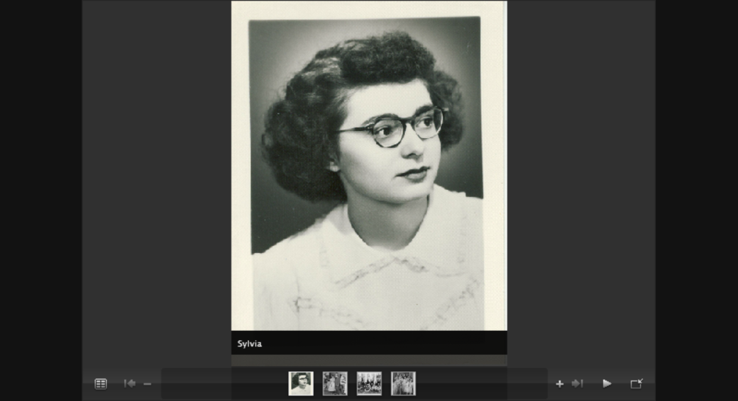

Sylvia Castelnovo

The first year of the Career Day (TFU), in 1992, Sylvia was the one receiving the registrations, because our mail was frequently misdelivered to the same house number in a different neighborhood. I didn’t want to miss any of these forms, so I asked Sylvia if she’d receive them and, of course, she agreed. Then, because this was our first year, I called her every day to see how many she had gotten. We had fewer than 100 and came close to cancelling, but with Sylvia’s encouragement, we went ahead and had a successful morning.

As is the case with good friends, we shared our joys and tribulations along with our love of music, gardening, politics and literature. It was sad to see her decline so rapidly these last two years. I miss her, a dear and true friend.

**By Marjorie Rowley.** Sylvia and I really connected about three years ago, when she was housebound due to her husband Tony's illness, and I was bed bound with a badly swollen leg.

We used to chat to each other by telephone each morning. At that time I promised her that we would make an effort to attend a movie each Wednesday, when we were both able to leave our respective homes.

Once we were able to keep this arrangement, it was possible for me to take her away from her home for a break. We had lunch at the Thai restaurant near the cinema and then settled down at Cinema Arts to enjoy, or at least be distracted by, whatever film was showing.

In retrospect, this was a precious time which I will always remember as a very special opportunity to really get to know this very special, warm, and sensitive friend.

**Calendar**

**Branch Board Meeting**  
Wednesday, March 27, 7–9 p.m.  
Home of Dianne Blais

***The Invisible War* Screening**Thursday, March 28  
Johnson Center Cinema, GMU

**State Conference**Saturday, April 13  
Richmond

**Branch Annual Meeting**Saturday, April 20 *Historical Women of Fairfax*Speaker: Lynn Garvey Hodge  
Oakton Library

#### Interest Groups

#### Bridge

The bridge group will continue to meet on a regular basis. For more information contact Charlene Comtois, 703/323-7747 or [charcomt@aol.com](mailto:charcomt@aol.com).

#### Salon Discussion Group

**Friday, March 8 from 12 to 2:00 p.m**.   
Home of Ann Slomski  
[anabbott@verizon.net](mailto:anabbott@verizon.net)

Dianne Blais will moderate a discussion of the first chapter in the *Great Decisions Briefing Book*, “Future of the Euro.”

Bring your own lunch and Ann will provide beverages and dessert. Please let her know by Wednesday, March 6, if you will be coming.

**Night Owls Book Discussion Group**

**Tuesday, March 12 at 6:30 p.m.**  
Home of Sonja Palomaki  
[spalomaki@dspalomaki.com](mailto:spalomaki@dspalomaki.com)

Light supper at 6:30 followed by our discussion of the*Sense of an Ending* by Julien Barnes led by Jan Humphrey. Please let Sonja know if you will be attending.

Upcoming books:  
April 9—*The Submission* by Amy Waldman  
May 14—*Winesburg, Ohio* (short stories) by Sherwood Anderson

#### Afternoon Literature

**Wednesday, March 20 at 1 p.m.**  
Home of Shirley Dwelley   
[HLDwelley@aol.com](mailto:HLDwelley@aol.com)

We will discuss Madeleine Albright’s *Prague Winter*. Do let Shirley know you’ll be there.

#### Musical Notes

**Friday, March 29 at 1 p.m.**  
Home of Kay Corbett  
[kaycorbett1@msn.com](mailto:kaycorbett1@msn.com)

Kay has graciously agreed to host us for the second half of *I Puritani.* Her big screen will enhance our enjoyment of this unfamiliar work by Bellini. Be sure to let Kay know that you will join us.

C:\Users\Owner\AppData\Local\Microsoft\Windows\Temporary Internet Files\Content.IE5\NB85KCJ3\MC900440221[1].wmf

**AAUW—FAIRFAX CITY BRANCH**

**MEMBERSHIP APPLICATION**

Membership is open to holders of an associate’s or equivalent, bachelor’s, or higher degree from a qualified institution.

Name:________________________________________________________________

Address: _____________________________________________________________

City, State, Zip:_________________________________________________________

Phone: (H)____________________ (W)__________________ (C) _______________

E-Mail: _______________________________________________________________

Degree: _______ College: ___________________________ Field: _______________

Degree: _______ College: ___________________________ Field: _______________

This information will be published in our directory and newsletter, unless you indicate items to omit.

DUES collected after March 15 for up to 15 months of membership:

$82 ($49 national, $15 state, $18 branch) for membership through June 30, 2014.

Note: $46 of the national dues is tax deductible.

Make check payable to AAUW—Fairfax City Branch.

Send this form and your check to the treasurer:

Jan Humphrey

3604 Gawaine Ct.

Annandale, VA 22003

**Springfield-Annandale Branch Spring Fling**

Saturday, March 9, 11 a.m. to 2:30 p.m.

The tickets; which include the silent auction, luncheon, and our speaker, China expert Michael Colopy; are $38 each. They will be available by mail, phone, or email. Contact Rose Clark at springfling@rclark.net or 703/256-6246.

To order tickets by mail, make checks payable to: Springfield-Annandale AAUW. Please mail your checks to Rose Clark, 4927A Sunset Lane, Annandale, VA 22003.

Deadline for purchasing tickets is Monday, March 4, 2013.

# OFFICERS AND COMMITTEE CHAIRS

###### **Branch Website**

[**fairfaxcity-va.aauw.net/**](http://www.aauwofva.org/branches/fairfaxcity.htm)

**Co-President: Ann Abbott Slomski**

**(anabbott@verizon.net)**

**Co-President: Leslie Vandivere**

**(lvandivere@cox.net)**

**Co-Program Vice President: Kay Corbett**

**(kaycorbett1@msn.com)**

**Co-Program Vice President: Trudi Arnold**

**(trudia1@juno.com)**

**Membership Vice President: Dottie Joslin**

**(j.joslin3@verizon.net)**

**Co-Secretaries: Dianne Blais**

**(dianneblais@aol.com**

**Prativa Prasad**

**(balramprasad@gmail.com)**

**Treasurer: Jan Humphrey**

**(dandjhumph@aol.com)**

**AAUW Funds and Scholarship:**

**Cindy Greenspan**

**(**[**cindy@dbls.com**](mailto:cindy@dbls.com)**)**

**Public Policy: Renee Prasad**

**(reneemprasad@hotmail.com)**

**Branch and Major Event Chairs**

**Newsletter Editor: Charlene Comtois**

**(Charcomt@aol.com)**

**Directory: Dottie Joslin, Leslie Vandivere**



**Penny C. Welke**

Attorney at Law

**Crickenberger & Welke Area Code: 703**

**Fairfax Commons, Suite 71B Telephone: 691-8900**

**3921 Old Lee Highway Fax: 691-1088**

**Fairfax, Virginia 22030 Residence: 323-7313**

**Book and Author Luncheon:**

**Barbara Klementz**

**(brbklm5@verizon.net)**

**Suzanne Mahoney**

**(suzanne070946@mac.com)**

**Career Day for Middle School Girls:**

**Coordinator: Suzanne Mahoney**

**(suzanne070946@mac.com)**

**Olga Burns**

**(rubato12@aol.com)**

**Interest Group Chairs**

**Bridge: Charlene Comtois**

**(Charcomt@aol.com)**

**Afternoon Literature: Renee Prasad**

**(reneemprasad@hotmail.com)**

**Night Owls: Paulette Miller**

**(psmiller10847@verizon.net)**

**Salon Discussion : Kathleen Henry**

**(kchenry@aeitv.net)**

**Musical Notes: Olga Burns**

**(rubato12@aol.com)**

**********************************************************************************************************

AAUW advances equity for women and girls through advocacy, education, philanthropy, and research.

In principle and in practice, AAUW values and seeks a diverse membership. There shall be no barriers to full participation in this organization on the basis of gender, race, creed, age, sexual orientation, national origin, disability, or class.

The AAUW Educational Foundation provides funds to advance education, research, and self-development for women and to foster equity and positive societal change.

The AAUW Legal Advocacy Fund provides funding and a support system for women seeking judicial redress for sex discrimination.



Leslie Vandivere

13825 Baywood Ct.

Centreville, VA 20120