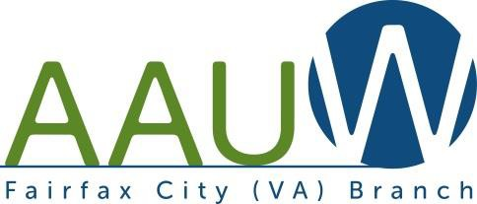
FSeptembOer 2017 CUVolumeS44, No. 1

Speaker
Book & Author Luncheon, 2017 Gerrymandering in Virginia
Liz White
Thursday, September 7 at 7 pm Kings Park Library
Book and Author Luncheon

Gerrymandering, or drawing of congressional districts to favor one political party, has a long history in the United States. In 1812, Massachusetts Governor Elbridge Gerry made efforts to set up districts to favor his political party.
Political experts consider Virginia to be one of the most gerrymandered of the fifty states. Gerrymandering has created bizarrely shaped districts whose boundaries are drawn based on voting patterns.
Our speaker, Liz White, is from the nonpartisan OneVirginia2021: Virginians for Fair Redistricting. Their mission is “to advocate for the adoption of an amendment to the Virginia Constitution that will establish an independent, impartial commission to apply a fair and transparent process in drawing political districts after the 2020 census.” Ms. White will discuss gerrymandering practices and their impact and voter action to create reform solutions.

With the hot summer almost history, we look forward to putting together the 26th version of our annual fundraiser, the Book & Author Luncheon. The highlight, of course, is the five authors who are ready to tell us about their books and themselves. Are you ready to be entertained and motivated to buy and read?

Silent Auction
A fabulous Silent Auction will present a wide variety of delights as we all remember to revisit our generous past donors and ask them to contribute once again. Many of our contributors are more than willing to participate, but need to be contacted well in advance. Begin now, too, to consider your own special donation to help fill the room with enticing treasures. Let Sonja Palomaki (spalomaki @dspalomaki.com) know what you plan to contribute.
Remember to invite your favorite guests and even invite someone new to our yearly scholarship fund raiser. Think B&A NOW, and we will have a successful, fun event. As always, our goal is to have a substantial scholarship to present to a deserving student in the spring.

Mark your calendar for October 28, from 11 to 2 at the Springfield Golf and Country Club. See the flyer included in this issue for information about reservations and other details.
In this issue:
Book & Author Luncheon 1
From the President 2
Membership 2
Special Election 3
Summer Party 3
Outlook is going Digital 3
AAUWFC Approved Branch Budget 4
More on the Gender Pay Gap 4
Office of Civil Rights in the USDE 5
OCR and the DE Standard of Proof 5
AAUW Public Policy 6
AAUW National Convention 7
News, Blues, and How to Defuse 9
Deeper in Debt 9
Scholarship Report 10
Do You Know About 10
2017 Spring Luncheon 11
Silent Auction Request 12
Interest Groups 13
Calendar 14
Book & Author Flyer 16

From the President

By Gale Rogers
Welcome back to a busy AAUW year! A lot of wonderful activities have already been planned and dates set. Bring out your calendar right now and save all the dates!
As always, we start each year with great plans and the best intentions. But nothing can be achieved without help from every member of the Branch. If you have not yet committed to having fun with the Branch to support our events, please make that plan at the same time as you note the dates on your calendar. There are lots of things you can do to help, many of them right from your own home!
Our most critical need is for leadership positions. This year we still urgently need a Co-Vice President for Membership to help
Sue Manganiello, especially during the months she will be traveling (January thru March; yes, she will be gone during STEMtastics). Talk to Sue about how you might be able to help. You’ll work closely with former membership vice president Dottie Joslin, so there will be plenty of support.
We also need fresh eyes and ears for the Nominating Committee as we will be electing the VP for Program and the Secretary this year. Email me or Dottie Joslin for background on what this entails.
Leslie also does far too much for the Branch and the State. Email her to ask what kinds of things she needs support with.
And with Suzanne Mahoney’s departure from the area, we need help with STEMtastics. I am temporarily acting as co- chair with Judy Page of Vienna, but we really need someone with more time to manage this permanently. Email me if this is something you might be willing to do.

Membership

By Sue Manganiello
As of August 14, the Fairfax City Branch has 55 members. I am pleased to welcome three new members: Roohi Hussain, Georgia Koliopoulos, and Ellen Hunt. Be sure to introduce yourself to them at the next meeting.
If you have any friends or neighbors who might be interested in joining AAUW, please have them contact me at (703) 475-7007 or smango54@yahoo.com. Remember that anyone who joins at a meeting or event such as the Book & Author Luncheon only pays half the national dues, thanks to AAUW’s Shape the Future program.
Would you like to attend a meeting or event, but need a ride? Let me know and I will find someone who lives in your area and is attending to arrange a carpool.

Special Election
If you live in Fairfax City, don’t forget the September 12 special election for an at-large seat on the City Council. Karen Habitzreuther and Jennifer Passey, both running as Independents, are competing for the slot.

2017 Summer Party
Old Mom Nature once again played games with us on the afternoon of July 22! She set out plenty of clouds, told the Rainmakers to prepare a deluge, and, after a little pleading from some of us, convinced them to hold off for a while. The swimming crowd managed some important floating and discussed high-brow issues in the pool, while the dry land folks resolved some of the day’s critical problems in the gazebo.
Many thanks to our hosts Olga and Bob Burns for opening their home and pool for our use, as they have done for more years than we like to think about. We gave Olga a rousing “Happy Birthday” as an early celebration of that occasion.
Kelly Espy and her band of merry cooks did Jennifer Vincent a great job organizing and setting out a feast of American BBQ and all the side dishes you could want. Thanks to Sonja Palomaki for making the tables look cheerfully American.
On the way home, the Rainmakers finally got their way, and we all used our windshield wipers on high. Better late than early.
Outlook Is Going Digital!
Starting with the summer 2017 issue, AAUW Outlook will be going digital. You’ll still get the same insight about the issues that affect women and girls the most, but with more content.
Make sure AAUW has your preferred email address on file, and look out for this issue in your inbox!

AAUW Fairfax City Branch Approved Budget 2017-2018

AAUW--Fairfax City Branch National and State dues are omitted, as they are passed through. | Budget 2016–  2017 | Actuals 7/1/2016–  6/30/2017 | Aproved Budget 2017-2018
INCOME
Branch Dues, 52 members @ $18 | 936 | 651.00 | Branch dues, 50 members @ $13 | 650
Book & Author Lunchn & AAUW Fund | 9,700 | 12,283.52 | Book & Author Luncheon & AAUW  Fund | 10,500
STEMtastics (incl $150 from Fx City Br) | 5,470 | 6,244.59 | STEMtastics (incl $150 from Ffx City  Branch) | 6,000
Focus Ad | 25 | 25.00 | Focus Ad | 25
Banquet Receipts | 970 | 960.00 | Banquet Receipts | 960
Holiday Party Receipts | 320 | 300.00 | Holiday Party Receipts | 300
Donations to Branch Operations | 0 | 0.00 | Donations to Branch Operations | 0
Other Income | 0 | 28.61 | Other Income | 0
Total Income | 17,421 | 20,492.72 | Total Income | 18,435
EXPENSES
Dues, AAUW of VA Northern District | 10 | 10.00 | Dues to AAUW of Virginia Northern  District | 10
Book & Author Luncheon Expenses | 5,200 | 4,815.94 | Book & Author Luncheon Expenses | 5,000
Scholarship awards | 3,000 | 6,000.00 | Scholarship awards | 4,000
AAUW Fund Donation ($30 * 50) | 1,500 | 1,900.00 | AAUW Fund Donation ($30 * 50) | 1,500
STEMtastics | 4,860 | 2,928.73 | STEMtastics | 6,500
Bank Charges (checks, deposit slips) | 0 | 0.00 | Bank Charges (checkbooks, deposit slips) | 0
Conventions (@ $50 for five persons) | 250 | 0.00 | Conventions (at $50 for five persons) | 250
Focus | 50 | 0.00 | Focus | 50
Insurance (every 3 years, paid 10-  2016) | 230 | 200.00 | Insurance (paid every 3 years, due 10-  2019) | 0
President | 15 | 0.00 | President | 15
Program | 125 | 0.00 | Program | 125
Membership | 100 | 0.00 | Membership | 100
Treasurer (including audit) | 0 | 0.00 | Treasurer (including audit) | 0
Hospitality | 50 | 0.00 | Hospitality | 50
Banquet Expenses | 990 | 887.44 | Banquet Expenses | 960
Holiday Party Reimbursements | 320 | 295.50 | Holiday Party Reimbursements | 300
Other Expenses (donation to STEM) | 0 | 150.00 | Other Expenses (donation to STEM) | 150
Total Expenses | 16,700 | 17,187.61 | Total Expenses | 19,010

More on the Gender Pay Gap
According to a couple of recent studies, the gender pay gap widens sharply when women are in their late 20s to their mid- 30s—just when they are having children.
The gap is much smaller for unmarried women without children.
The presence of children is especially deleterious to salaries of college-educated women because they are more likely to be in higher paying jobs. The data in these studies indicate that college-educated women age 25 make about 90 percent of men’s salaries and at age 45, the figure is about 55 percent.
During this period, women’s pay often goes into a vicious cycle. Because they earn less,

they may do more of the child care. This can lead to cutting back their work hours, being less likely to take on greater job responsibilities, relocating (and changing jobs) to accommodate their partners, and so on.
These factors result in women’s failure to get raises and promotions within their company at the same rate as male employees. The researchers estimate that 73 percent of the pay gap is attributable to this factor.
Remedies to reduce the pay gap include putting less emphasis on long hours, allowing more telecommuting, making subsidized child care available, and providing longer parental leave.
Source: Claire Cain Miller, “The gender pay gap is largely because of motherhood,” New York Times, May 13, 2017.

Office of Civil Rights in the U.S. Department of Education
For several years, AAUW has been a strong supporter of Title IX, the federal law that protects the rights of women and girls in public schools and universities, including how instances of gender discrimination and sexual assault are handled.
The Office of Civil Rights (OCR) in the Department of Education announced in June that it was cutting back its enforcement efforts. This is in line with Secretary Betsy De Vos’s Congressional testimony and other statements in which she made no commitment to enforce federal civil rights laws. The recently appointed head of OCR, Candice Jackson, has never worked in civil rights enforcement and has criticized both affirmative action and the women’s movement.
According to the latest announcement, regional OCR offices will not be required to report complaints on issues such as the disciplining of minority students and the
handling of sexual assaults on college campuses. While it is true that OCR has been overburdened with investigations, the new policies will allow attention to these issues to wane and the civil rights of women and LGBTQ students to be neglected without recourse. The guidance and technical assistance furnished by OCR to schools regarding their compliance with Title IX has resulted in better outcomes and safer environments for many students.
Future assistance of this type is in jeopardy.
The current administration’s budget proposal gives OCR an additional kick in the guts. It calls for a cut of more than 40 positions.
Sources: Erica L. Green, “Education Dept. Says It Will Scale Back Civil Rights Investigations,” New York Times, June 17, 2017; Erica L. Green, “Some Hires by Betsy DeVos Are a Stark Departure From Her Reputation,” New York Times, June 2, 2017.

OCR and the Department of Education: Standard of Proof
Federal civil rights law (Title IX) specifies that in cases of sexual assault at universities and other schools that receive federal funding, evidence that the assault has occurred must meet the standard of proof called a “preponderance of the evidence.” This standard is used in most civil lawsuits. It contrasts with the better known “beyond a reasonable doubt” standard, which requires a higher level of proof and is therefore more favorable toward the accused. Secretary of Education Betsy DeVos is considering eliminating the “preponderance” standard. Many fear that she will substitute the tougher standard and thus introduce bias against the accusers, who are mostly female.
Title IX treats sexual assault as a violation of civil rights. For many survivors, reporting an assault to campus officials is preferable to reporting it to law enforcement. In fact, only a small percentage of rapes and sexual

assaults is reported to police. As it currently stands, Title IX provides many with an alternative to public accusations, extra expense, and added red tape.
For more information, see Jon Krakauer’s book, Missoula: Rape and the Justice System in a College Town. It uses as a case study the stories of several of the hundreds of women who reported sexual assaults at the University of Montana between 2008 and 2012.
Source: Jon Krakauer and Laura L. Dunn, “Don’t Weaken Title IX Campus Sex Assault Policies,” New York Times, Aug. 3, 2017.

AAUW Public Policy
To help members understand what AAUW does to influence public policy at the federal and state levels and on social
media, Lisa Maatz, former AAUW Vice President of Government Relations and Advocacy, provided the following information that gives a snapshot of the work being
percent were sent to the Senate, and 7 percent were sent to the Trump Administration.
- Spoke at Equal Pay Day press conference with Sen. Patty Murray, Rep. Nancy Pelosi, and others
- Joined Sen. Dianne Feinstein, Rep. Ann Kuster, Sen. Kamala D. Harris, and others in hosting a Congressional reception focused on policies to prevent sexual assault and harassment in middle and high schools.

State
- AAUW Public Policy staff are currently monitoring 1,480 bills in the 2017 state legislative sessions. Bills are being monitored in all 50 states and the District of Columbia.
- AAUW received 57 requests to vet state legislation from members via the state legislative request intake form, and at least an additional 42 requests directly from members for assistance with analyzing legislation, drafting talking

done.

Federal
Lisa Maatz
points, or crafting testimony.
- AAUW Public Policy staff received 15 requests from state legislators or

  - Monitored 34 different bills in the 115th Congress.
  - Had 795 different interactions with Capitol Hill between January 1, 2017, and April 28, 2017.
  - Conducted almost 650 visits to Congressional offices through the Capitol Hill Lobby Corps. AAUW was mentioned in one floor statement from a Member of Congress and in nine Dear Colleague Letters from Members of Congress. AAUW was mentioned in 11 press releases from a Member of Congress.
  - Joined 52 sign-on letters with coalition partners.
  - Authored 14 letters. About half of these letters were sent to the House, 43
legislative staff in the states.
  - AAUW members are working diligently across the country to pass strong equal pay legislation. Puerto Rico, Philadelphia, and New York City (bill will be signed next week) have passed laws to help close the gender pay gap. Colorado also passed a bill that is awaiting gubernatorial signature. Overall, bills have been introduced in 41 states, Puerto Rico, and the District of Columbia in 2017.

Member Communications
  - AAUW members and supporters have received 29 federal Action Network emails this year. These alerts enable

AAUW advocates to act when their federal advocacy is needed most.
  - AAUW members and supporters have received 49 state Action Network emails this year. Co-authored by AAUW state leaders, these alerts call on AAUW advocates to act on pressing state legislative priorities.
  - In result of AAUW’s Action Networks, AAUW members and supporters have sent 63,972 messages to federal and state legislators this year.
  - In addition, AAUW members can sign up to receive Washington Update each Friday that Congress is in session.
And AAUW In the Statehouse once monthly. Washington Update offers an insider’s view on the legislative process, the latest public policy news, resources for advocates, programming ideas, and updates from the AAUW Public Policy and Government Relations Department. AAUW in the Statehouse provides updates on state policy from across the country, tips and resources for more effective advocacy, and insider information from the AAUW Public Policy and Government Relations Department about good and bad bills in the states.

Social Media
The @AAUWPolicy handle has earned 849K impressions, totaling around 8.5K impressions per day with 4K Retweets per day. This also includes five Facebook mentions from members of Congress along with 15 tweets from members of Congress on Equal Pay Day sharing our content.

Campaign Example: Equal Pay Day Twitter Metrics 2016 vs. 2017

EqualPayDay | 2016 | 2017
# of people participating | 2,391 | 21,497
# tweets sent | 4,075 | 30,902
Reach | 14.6 million | 173.3 million
Potential impressions | 26.9 million | 253.1 million
Traditional Media

 | Lisa Maatz | Anne Hedgepet h | Kate Nielson | Total
Advertising Value Equivalency  * | $4.9  Millio n | $430,000 | $350,00 0 | $5.7  Million
*AVE refers to cost of buying space taken up by a piece of media coverage, had that coverage been an advertisement.
Top Media Reach | 57.5  Millio n | 46, 600 | 40  Million | 97.6  Millio n
Press Hits 1/1-  4/25/2017 | 423 | 4 | 10 | 437
Highlights of the AAUW National Convention
By Dottie Joslin
Hundreds of AAUW members from all over the country gathered in Washington,
D.C. in June for the biennial AAUW National Convention. It was a pleasure to meet others, participate in Lobby Day, attend instructive workshops, and hear inspiring speakers.

Lobby Day
Informative meetings prepared delegates to lobby on two topics. The first addressed the burden of student debt. AAUW’s new research report, Deeper in Debt: Women and Student Loans, estimates that women hold almost two-thirds of the country’s $1.3- trillion student debt. Congress must safeguard and expand Pell grants for low- income students, as well as ensure that

nontraditional students have the resources they need, such as on-campus child care, to successfully complete college degrees.
Supporting income-driven repayment approaches and working to close the gender pay gap would help.
The second addressed civil rights protections in the Department of Education, especially enforcement of Title
IX. Congress must protect Title IX and provide resources to the Office of Civil Rights to ensure that all students are afforded equal access to education in schools free of discrimination.
On Lobby Day, hundreds of members delivered our messages to members of Congress from our respective states. The legislative aides of our Virginia senators and the congressman’s office I visited were very supportive.

National Election Outcomes on Membership Proposals
Both bylaws amendments pertaining to membership failed. There was an audible sigh of disappointment when it was announced that the proposed Advocate membership narrowly failed to achieve the necessary two-thirds vote. The proposed Advocate category would have allowed those who do not meet the membership degree requirements to join AAUW, but an Advocate could not hold the office of branch president or treasurer or national positions. The proposal to eliminate the degree requirement failed by a large margin.

The Financial Status of AAUW and Dues
The good news: The Charting the Course fundraising campaign exceeded its goal to raise $1 million.
The bad news: AAUW’s financial condition is under stress. AAUW has cut staff and narrowed programs. The registration fees for National Convention did not anywhere near cover its cost. More than $1 million in
unrestricted funds were used to close the gap.
The next National Convention will be held in 2020, three years away instead of two, to celebrate the 100th anniversary of women’s right to vote. This also postpones the cost of Convention for a year.
National dues will increase by $10 (to $59) beginning next year, 2018–19. Our new CEO, Kimberly Churches, and our newly elected President, Julia Brown, are prepared to face many challenges.

Three Inspiring Women
Who skillfully reformats news coverage at the last minute before a broadcast or even during it? That’s unflappable Judy Woodruff, anchor of the PBS NewsHour. She described how breaking news alters the story lineup. Her uneducated mother’s insistence on the power of education set Judy on her path. An indefatigable journalist, she assured us that she’ll continue until she dies.
What African woman established 11 schools that educate over 5,000 children in her impoverished homeland? That’s AAUW International Fellow and Oprah Winfrey’s “all-time favorite guest,” Dr. Tererai Trent. Oprah’s $1.5-million donation brought Dr. Trent’s determination to improve education in Zimbabwe to fruition. As an impoverished child in a rural village, Tererai’s dream was to achieve an education in America and return to help her community. Tererai confided her dreams to an aide worker, who said, “It is achievable.” This confidence fueled Tererai’s perseverance to fulfill her dream.
Who is the first Latina and the third woman to serve on the Supreme Court? Associate Justice Sonia Sotomayor told us that the Supreme Court was not a leader for women’s rights until the 1970s, when Ruth Bader Ginsburg won landmark gender

equality cases before the Supreme Court. Two early victories set a precedent for gender equality by providing benefits for women that had been available only to men.
To engender civic awareness, Sotomayor recommended ICivics.org, a website created by Sandra Day O’Connor. Sotomayor asserted that we cannot be bystanders to life: we must do something to change laws we don’t like. She emphasized that the only path to equality is education.
This was the first time I attended the National Convention, and I’m glad I did. It was fun, engaging, and informative and provided an opportunity to meet members from other parts of the country. Many inspiring women made this convention a memorable experience.

News, Blues, and How to Defuse
Fairfax County Public Library and George Mason University’s School of Conflict Analysis and Resolution are sponsoring a series of interactive workshops about media literacy and dialogue skills. Learn about navigating through news sources. Practice using respectful and positive communication techniques when discussing hot-button issues.
Workshops will be held at 7 pm at regional libraries on the following dates: September 22 (Sherwood), October 23 (Reston), and November 15 (Pohick). Register online at http://librarycalendar.fairfaxcounty.gov.
Deeper in Debt
AAUW’s latest research report, Deeper in Debt, which examines the burden of student loan debt on women, was published in May 2017.
Currently, about 44 million borrowers in the United States hold about $1.3 trillion in outstanding student loans. The research
reported in this publication indicates the extent to which student loan debt is heavier and more difficult to repay for women than for men. Women take on larger student loans than do men. And because of the gender pay gap, they have less disposable income with which to repay their loans after graduating from college, so they require more time to pay back their student debt than do men. As a result, women hold nearly two-thirds of the outstanding student debt in the United States.
Women are more likely to take on debt; 44 percent of female undergraduates take on debt in a year compared to 39 percent of male undergraduates. On average women take on more debt than men at almost every degree level and type. By the time they earn a bachelor’s degree, women’s average accrued student debt is about $1,500 greater than men’s, and black women take on more student debt on average than do members of any other group.
Because women working full time with college degrees make 26 percent less than their male counterparts, they are slower than men to pay off this debt. During the first four years after graduation, men pay off an average of 38 percent of their outstanding debt, while women pay off 31 percent. Loan default rates are higher for women, especially for Black and Hispanic women, than for men.
To ameliorate the problems of women’s student debt, AAUW advocates safeguarding and expanding Pell grants for low-income students, customizing repayment plans, and providing resources such as on-campus child care to assist women in completing degree programs.
To download the full report, go to http://www.aauw.org/resource/deeper-in- debt/

Scholarship Report
The scholarship committee announces that the recipient of the AAUW Fairfax City Branch Beverly Anderson Memorial
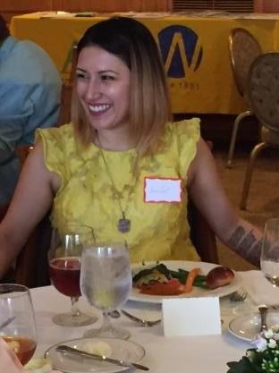
Scholarship for 2017 is Jennifer Vincent. Jennifer is on schedule to graduate from George Mason University in May 2018 with a bachelor’s degree in psychology.
We award this funding to a woman attending Mason who has had an interruption in her journey to complete her undergraduate degree. Jennifer graduated from High School in 2005. Her educational odyssey took her from her home in San Antonio to California State University, Northridge and finally to GMU. Supporting herself, often struggling financially, and sometimes forced to choose work over school, she never lost sight of the importance of obtaining a degree and never gave up on her dream.
The committee recognized Jennifer’s determination, growing maturity, and the clear focus of her goals. While at Mason she has maintained exemplary grades, and is currently on the Dean’s List.
In his letter of recommendation, a professor wrote:
I am convinced that Jennifer’s passionate yet unpretentious nature, combined with excellent writing and communication skills, will allow her to succeed at a very high academic level. In my opinion, she exhibits all of the qualities necessary to meet and to surpass the goals and requirements set forth by the psychology department at George Mason University.
We were delighted to meet Jennifer at our May banquet, and we look forward to following her continued success.
Thank you to committee members Kelly Espy and Sandy Mathews for their dedication and hard work.

Do You Know About . . .
Dianne Blais would like to share word of three of her special interests.
- Friends of Theatre at Mason (FOTM;
http://theater.gmu.edu/affiliates/friends.html)
Please consider attending the GMU student productions. When you attend the productions, you’ll want to join FOTM, but, of course, you can enjoy the plays without joining. Next year’s season sounds terrific, but this school year you can still catch Gogol’s The Nose and Other Strange Tales from the City and The Annual Ten-Minute Play Festival.
  - Dining for Women (http://diningforwomen.org/)
Perhaps more people are interested in this group since my earlier email. One local chapter of this national giving circle meets at my house the first Sunday of each month, watches and discusses the month’s video of the featured grantee, and then dines, typically on the food from the featured country. Projects supported by the group are designed to reduce poverty and promote gender equality.
  - Virginia International University (VIU; across from the Wegmans on Rte. 29)
Moving to another country is challenging. VIU is starting a Friends group. I currently have three VIU master’s students from Mongolia, Vietnam, and Pakistan living with me. Please contact me if you are interested.

2017 Spring Luncheon
A good turnout of long-time and new members, along with guests, enjoyed our banquet at the Country Club of Fairfax way back in May. The chill in the air outside wasn’t noticeable in the room where we ate, and voices were in animated discussion at every table.
President Gale Rogers helped us dispatch our business in quick order. We voted to reduce branch dues to $13 and elected three officers for next year. Congratulations to Gale Rogers (starting a second term as President), Sue Manganiello (our new Vice President for Membership), and Dottie Joslin (starting a second term as Treasurer). We met Jennifer Vincent, winner of our Beverly Anderson Scholarship at George Mason University (see separate article).
And last, but hardly least, we honored Trudi Arnold, who has reached the 50-year milestone of AAUW membership and is one of the branch’s “founding mothers.”
Speaker Roohi Husain, senior public health program manager with UNICEF, described the strategies she has used to achieve an immunization rate of 99 percent for infants in Zambia and to help reduce the prevalence of AIDS in Uganda. She is passionate about her work, which she sums up as “education, advocacy, and action.”

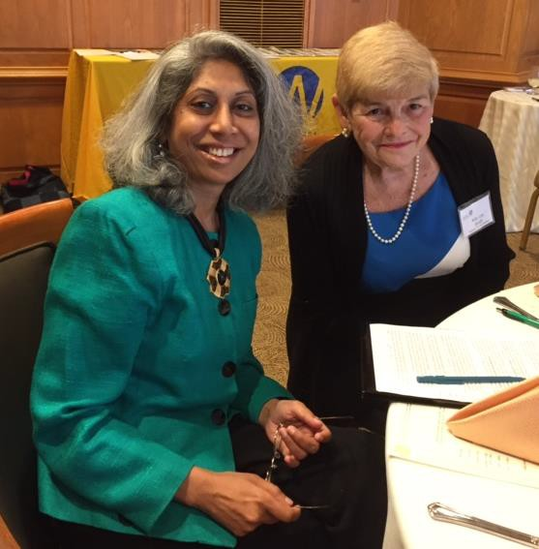
Roohi Husain and Kitty Lou Smith

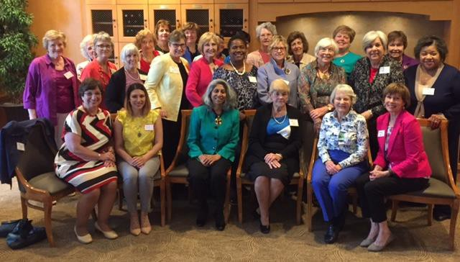
AAUW Fairfax City Branch Members and Roohi
Husain

Silent Auction Request
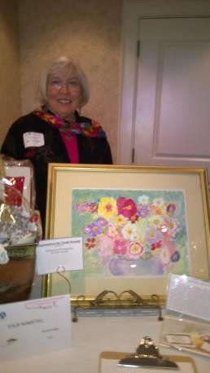
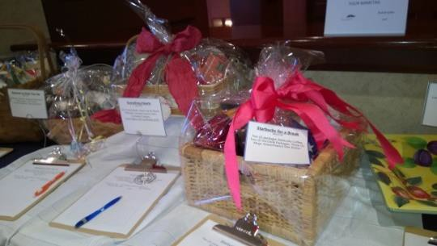
How do you motivate members each year to donate to the Silent Auction? Get them to think about our scholarship program and the wonderful women who have benefitted from it!
In the past, many of you have responded with a plethora of items, gift cards, books and

baskets. Thank you! Can we do it again this year? You bet. But we need all our members to help make the 2017 Silent Auction a success.
Here are some ideas of what’s needed:
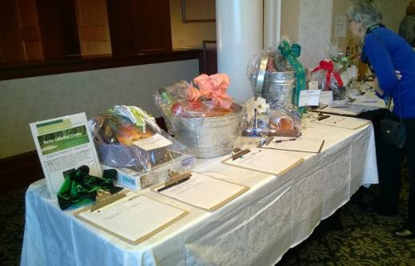
- New and slightly used books
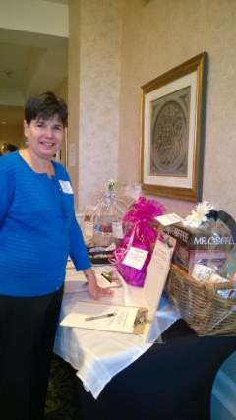
- Exercise items (already have a mat and water bottle)
- Gadgets, such as avocado slicer, olivator, back scratcher, grease splash guard, all-in-one tool, magnifying glass, staple-free stapler, stress relieving spinner, fancy paper weight
- Gift cards from restaurants, grocery stores, bakeries, gyms, theaters, movies, concerts,
florist, coffee shops, meat markets, wineries, golf course, jewelers, and others.
- Wine
- Margarita makings
- Tea and/or coffee items
- Beauty and/or salon products
- Decorative items
- Gourmet foods
- Baking products/supplies
- Bird feeder and related items
- Whatever would interest you!
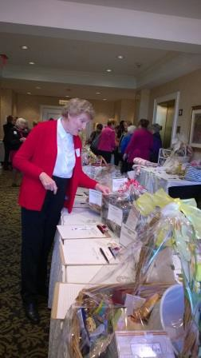
We have a large supply of baskets so there is no need to wrap up your donations. We will do that for you. Please drop off your donations at Ida Portland’s home, 10810 Glen Mist Lane, Fairfax (703/352-0125) on Sunday, October 22 (afternoon) or Monday, October 23.
Questions: Sonja Palomaki, Silent Auction Chair, (703)455- 6262 or spalomaki@dspalomaki.com

Afternoon Lit
Wednesday, September 20, at 1 p.m. Home of Prativa Prasad
9030 Scott Scott Street, Springfield balramprasad@gmail.com 703/866-4038
Please let Prativa know by Sunday,

Interest Groups
We’ll start with dessert, followed
by watching a very special tape of Jacques Offenbach’s Tales of Hoffman. This is a film adaptation produced in England with Moira Shearer and Robert Rounsville and is a true fantasy feast for the eyes. This group meets on the last Friday of the month to watch operas, viewing the first half one month and

September 17, if you plan to attend. The group will discuss The Handmaid's Tale, by Margaret Atwood.

Great Decisions–Salon Discussion Group
Friday, September 15, at 12 noon Home of Kay Corbett
7226 Clifton Rd., Clifton Kaycorbett1@msn.com 703/222-6012
Because of Labor Day we will have the meeting on the third Friday in September. We are continuing the 2017 edition of the Foreign Policy Association’s Great Decisions with topic five, “Geopolitics of Energy.” All members are welcome to attend. We will listen to a 30-minute DVD on the topic that accompanies the briefing book.
Please let the hostess know if you are coming. Bring a light lunch. Drinks and dessert will be provided.

Lunch Bunch
Wednesday, October 4 at 11:00 am Clifton Cafe
7144 Main Street, Clifton.
Please email Gale Rogers if you can come (gale.rogers63@gmail.com).

Musical Notes
Friday, September 29, at 1 p.m. Home of Olga Burns
10623 Timberidge Road Fairfax Station rubato12@aol.com
703/239-2876
the second the following. All are welcome; just let Olga know if you intend to come.

Night Owls
Tuesday, Tuesday, September 12, 6:30 p.m.
Home of Judy Weltz
10522 Rosehaven Street, Fairfax jolegp@msn.com
703/272-8242
Light supper will be followed by our discussion of The Underground Railroad by Colson Whitehead, led by Judy Weltz.
Please let Judy know if you will be attending. Parking on the street is limited, so carpooling is recommended.

Books
For planning purposes, below is a list of the books we will be reading through April:
October 10, The Story of a New Name, by Elena Ferrante
November 14, The Widow, by Fiona Barton
December 12, Commonwealth, by Ann Patchett
January 9, A Man Called Ove, by Frederick Backman
February Sat. (TBD), Americanah, by Chimamanda Ngozi Adichie
March 13, A Rose, by Louise Erdrich April 10, The Tea Girl of Hummingbird Lane,
by Lisa See

Calendar of Branch Events
TBD, Northern Virginia District Meeting Oct. 28, 11-2, Book & Author Luncheon
Jan. 20. A docent at the African American Museum of History and Culture will outline the museum’s collection and discuss its impact on the museum’s visitors.
Dec., Holiday Party, TBD
Jan. 20, 1 p.m., Meeting on the African American Museum of History and Culture
Feb. 17, 1 p.m., Meeting on the opioid crisis. A representative from the Fairfax County Community Services Board will give a presentation on the opioid crisis—its prevalence, its effects, and policy recommendations to reduce its tragic costs.
Mar. 10, 6:30 am STEMtastics
Apr. 19, 7 p.m., April 19. A microbiologist from the U.S. Geological Survey will discuss STEM issues and the practical applications of her research.
May, Spring Luncheon, TBD

Advancing equity for women and girls through advocacy, education, philanthropy, and research.
AAUW FAIRFAX CITY BRANCH MEMBERSHIP APPLICATION and RENEWAL
Membership is open to all graduates who have a two-year, RN, four-year, or higher degree from an accredited institution. AAUW values and seeks a diverse membership.

You can join or renew online at www.aauw.org. Click on Membership> Join/Renew> Branch Member. Follow the
prompts. We are “VA3042 Fairfax City.”
Or, Complete the application below and mail it with your check to the treasurer. Name: Address: City, State, Zip: Phone: (H) (W) (C) E-Mail: Degree: College: Field: Degree: College: Field:
This information will be published in our directory and newsletter, unless you indicate items to omit.

DUES: $82 ($49 national, $15 state, $18 branch) for membership through June 30, 2017. Note: $46 of the national dues is tax deductible.

If transferring from National Membership or another branch, submit dues to the treasurer: If your National membership expires in 2016, remit $82.
If your National membership expires in 2017, remit $33.
Contact Joan Dimengo: C 703/203-2765 H 703/815-1586 or email jdimengo@gmail.com for verification of the dues amount.

AAUW ID #, if known: Dues enclosed for transfer:

National membership expiration date:

Make check payable to AAUW Fairfax City Branch.
Send this form and your check to the treasurer: Dottie Joslin
11110 Del Rio Dr.
Fairfax, VA 22030-5339 j.joslin@verizon.net or 703/591-9035

Would you be willing to bring someone to our meetings and events if she lives in your area? Yes or No Do you need transportation to our meetings and events? Yes or No

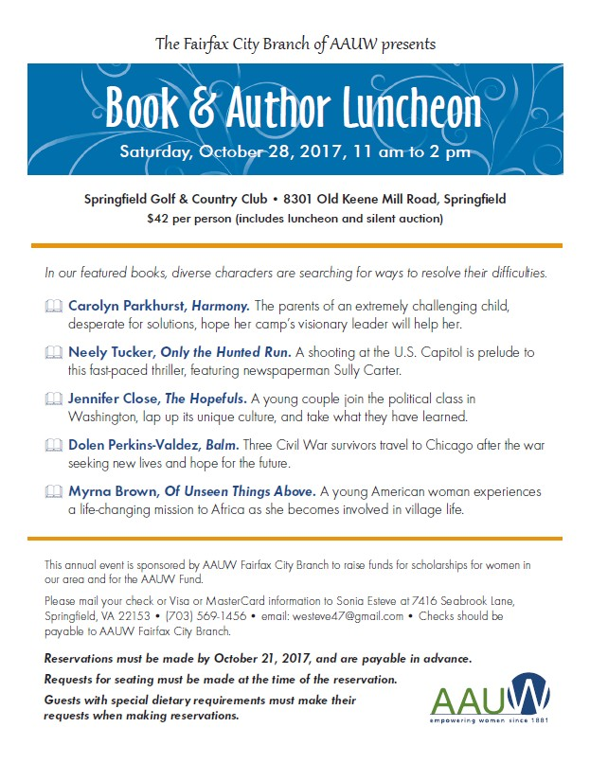

AAUW Fairfax City (VA) Branch FOCUS September 2017

Branch Website: http://fairfaxcity-va.aauw.net/

Officers:
President: Gale Rogers gale.rogers@denkifuro.com
Program Vice President:
Dianne Blais rubato12@aol.com Kitty Lou Smith
mailto:kittysmith@cox.net Membership Vice President:
Joan Dimengo jdimengo@gmail.com
Secretary: Anita Light anita.light95@gmail.com
Treasurer: Dottie Joslin j.joslin3@verizon.net
AAUW Funds and Scholarship:
Paulette Miller psmiller10847@verizon.net
Communication: Leslie Vandivere
lvandivere@cox.net Newsletter Editor: Jan Humphrey
dandjhumph@aol.com Web Manager: Leslie Vandivere
lvandivere@cox.net

Branch Event Chairs:
Book and Author Luncheon:
Barbara Klementz brbklm5@verizon.net Suzanne Mahoney

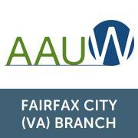
suzanne070946@mac.com
STEMtastics: Suzanne Mahoney suzanne070946@mac.com

Interest Group Chairs:

Afternoon Literature: Jean Arnold
arnoldjh52@aol.com
Night Owls: Paulette Miller psmiller10847@verizon.net
Salon Discussion Group: Kay Corbett kaycorbett1@msn.com
Musical Notes: Olga Burns rubato12@aol.com

Penny C. Welke
ATTORNEY AT LAW
Crickenberger & Welke | Area Code: 703
Fairfax Commons, Suite 71B | Telephone: 691-8900
3921 Old Lee Highway | Fax: 691-1088
Fairfax, Virginia 22030 | 3921Law@vacoxmail.com

17

