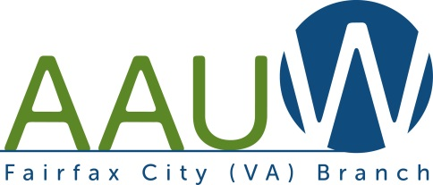
FOCUS
Volume 48, No. 1
Fall 2021
Celebrating 140 Years of AAUW!
AAUW’s story began in 1881, when a small group of female college graduates banded together to open the doors for women’s career advancement and to encourage more women to pursue higher education.

At that time, women faced significant barriers in accessing higher education and in pursuing jobs outside a limited number of fields. AAUW’s founding marked one of the first organized efforts to advance opportunities for women to pursue higher education and careers — and for equal treatment with men.

We launched one of the most enduring fellowship programs for women in the world. And we commissioned groundbreaking research that documented women’s abilities and equal value.
We’ve published hundreds of research reports, from an 1885 paper disproving a prevailing myth that college impairs a woman’s fertility to, most recently, a study documenting the economic impact of workplace sexual harassment. We have supported the academic achievements of many thousands of scholars, from scientist Marie Curie, the first woman to win a Nobel Prize, to astronaut Judith Resnik, the second woman in travel in space.

Our advocacy efforts have propelled countless new laws, including the Equal Pay Act, first proposed in 1945 and finally passed in 1963; the Title IX amendment in 1972; the Family and Medical Leave Act in 1993; the Lilly Ledbetter Fair Pay Act in 2009; and the Paycheck Fairness Act, which was passed by the U.S. Representatives in 2019 but is awaiting action in the Senate.

On Wednesday, November 17, at 4 p.m., as part of AAUW’s 140th anniversary celebration, AAUW will present our distinguished 2021 AAUW Alumnae Recognition Award to Ngozi Okonjo-Iweala, Ph.D., the first woman and first African to serve as Director-General of the World Trade Organization. View an exclusive conversation between Dr. Okonjo-Iweala and AAUW’s new CEO Gloria L. Blackwell.

Register to view the celebration at this link:
https://us02web.zoom.us/webinar/register/WN_f-FJ55kDQ9CVLOgFovWdmA?emci=fef7574e-e53c-ec11-9820-c896653b26c8&emdi=66cec7ae-403e-ec11-9820-c896653b26c8&ceid=913355

President’s Message: Keeping our Branch Alive

AAUW has played an important part of my life. I joined before my 4th child was born and quickly became involved. I’ve loved the AAUW book clubs, the informative meetings and working with AAUW members on projects. I’ve even enjoyed the many board meetings, on both the local and state level, the state and national conventions, and getting involved with AAUW public policy.

It is not easy to either start or end a branch, and although it is desirable that a branch be active, have many board positions filled and contribute significantly to AAUW, a branch only needs a president and treasurer to exist. Both Dottie Joslin (treasurer) and I (president) were elected for 2-year terms last May. We would love Fairfax City to be an active branch, but even if we’re not currently, it is possible that we might be in the future. Several members of our branch were involved with the latest GOTV effort of writing postcards. We are still doing something.

Because of Zoom (or other available apps), it is possible to be involved with AAUW at the branch, district, state and national level without leaving your house. Our branch doesn’t have to arrange programs as in the past because there are SO many programs available to us. I send an e-mail out almost weekly with an invitation to join an AAUW meeting.

AAUW has a mission that I want to support, and membership is the best way to support this mission. Please keep your membership in AAUW and evangelize to friends about this great organization. Let’s keep this branch alive!

Dianne Blais, president

Tour of the Turning Point Suffragist Memorial
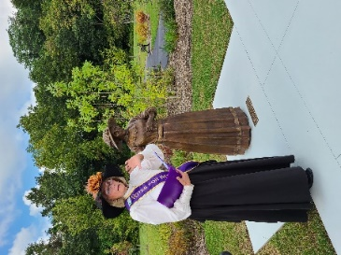
On a sunny September Saturday four Fairfax City Branch members were inspired by a tour of the new Turning Point Suffragist Memorial (TPSM), along with members of the Springfield/Annadale branch, who organized the event. We were privileged to have Pat Wirth, CEO of the TPSM Association, as our guide.
The Turning Point Suffragist Memorial honors the women who were imprisoned at the Occoquan Workhouse located across from the current Occoquan Regional Park and commemorates all of the millions of little-known women who engaged in the suffragist movement primarily from 1848 through passage of the 19th Amendment in 1920 that allowed most women to vote. This memorial is both a visual symbol and an educational tool that elevates them to their proper place in history.

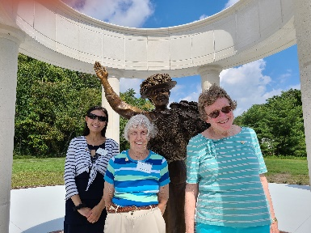
Hong Wang, Jan Humphrey, and Olga Burns at the Carrie Chapman Catt memorial at the TPSM in Lorton.

Public Policy: Members Write Postcards to Get Out the Vote

A total of 100 non-partisan Get Out the Vote postcards provided by AAUW-VA were written by four Fairfax City Branch members. We are proud to be participants in this initiative. A recent email from AAUW-VA Public Policy co-chairs stated:

“The AAUW-VA Board wishes to thank all our members who have so enthusiastically responded to our request for volunteers for the “Reclaim Our Vote” postcard writing campaign. We have distributed 1,480 addresses to the 18 Branches around the state who volunteered to help. AAUW-VA funded the postcards and labels for 1,500 cards and postage for 800. Branches and members contributed more than $200 in postage to cover the additional amount needed and time, effort, and ink, showing just how important Getting Out the Vote is to our members.”

ADOPTED BUDGET 2021-2022
INCOME
Branch dues: 20 members @ $13 | 260
Scholarship Fund | 1,000
AAUW Greatest Needs Fund | 840
Holiday Party Receipts | 0
Banquet Receipts | 0
Donations to Branch Operations | 0
Other Income | 0
Total Income | 2,100
EXPENSES
Dues to AAUW of Virginia Northern District | 10
Scholarship awards | 1,000
AAUW Greatest Needs Fund Donation (28X$30) | 840
Insurance (paid every 3 years, paid 10-2019) | 0
President | 15
Program (Zoom account, 1 year renewal) | 160
Membership | 0
Treasurer | 0
Bank Charges | 0
Hospitality | 0
Holiday Party Reimbursements | 0
Banquet or Party | 250
Archive Branch Records | 100
Other Expenses | 100
Total Expenses | 2,475
Net Income – Expenses | (375)
Cancellation of the Book & Author Event
In case you missed Paulette’s letter that was attached to a September email, here are edited excerpts from her letter to the branch:
Dear Fairfax City AAUW Branch Members,
It is with much sadness that I must tell you that there will be no Book and Author Event this year. Last year due to Covid-19 we moved our Luncheon to a virtual event. While it was simply not the same as our former event, it was a success considering there was no silent Auction. We did raise enough funds ($3,000!) to provide scholarship aid. The four wonderful authors were very gracious with their time.
However, this event did require a tremendous effort from a very small and very hard-working cadre of members. We had to consider whether it was going to be possible to continue this fund-raising event.
I sent invitations to many local authors to participate in a second virtual event. Whereas last year the response was positive and enthusiastic, this year it was not. Perhaps everyone has reached Zoom Event Burn-out. By the end of summer, I had only two authors willing to participate. We also doubted that sizable contributions to a second virtual event would be forthcoming. We decided to cancel the Book and Author event. It is simply so much work for so small a group of workers with very little expected result.
Thank you to everyone who has made the Book and Author Luncheon such a wonderful event over the past 26 years – the former chairs, the wonderful committee members and the faithful attendees. You have all provided many women with the means to complete their education and to go out and make a difference in the world.
Sincerely,
Paulette Miller, Chair
Book and Author Committee

Looking for Leaders
Each spring the Fairfax City Branch holds its annual election of officers. In 2022 the offices to be filled are program vice president and secretary. A member has agreed to be the candidate for secretary to serve after Anita Light’s two-year term ends. We are seeking a candidate for program vice president and also a membership vice president. The current leadership vacancies for program and membership hinder our ability to plan branch programs and increase our membership. We have 25 renewed members. AAUW will drop non-renewed members after November 30.

Our appointed board members and other leaders also continue to provide valuable service to the branch. The Night Owls Evening Literature group that meets over Zoom remains vibrant. Any branch member may participate. Responses to our summer survey indicate an interest in reviving other interest groups that ceased to meet due to the pandemic, but we lack leaders. Are you able to contribute to branch activity in any way, such as leading another interest group, arranging a one-time event or program, or filling an elected or appointed board position, such as public policy or diversion, equity, and inclusion? Please contact any board member if you can serve in any capacity.

Hear the Fairfax Registrar Discuss Voting Rights and our Recent Election

The Fairfax League of Women Voters invites you to hear Scott Konopasek, Director of the Fairfax County Office of Elections and General Registrar via Zoom on November 21 at 2 pm. As the speaker at the LWVFA’s general meeting, he is to address the topic How Recent Voting Rights Reforms in Virginia have Affected Voter Involvement.

You may register for this virtual event using the link below. If you have questions for Mr. Konopasek, you may submit them as you register. You will also be able to submit questions through the ZOOM chat at the time of the event. People who register will receive a ZOOM link before the event.

https://lwvfa-november-21.eventbright.com/

If you have questions about this meeting, please contact Barbara Boardman. (barbara.boardman@lwv-fairfax.org)
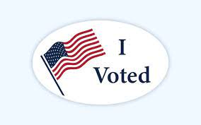

December 10 – World Human Rights Day and Jane Addams Day

On December 10, 1931, Jane Addams became the first American woman to receive the Nobel Prize for Peace, honoring her work including her leadership of the Women's International League for Peace and Freedom (WILPF).

Jane Addams was a founding member of the AAUW Chicago (IL) Branch in 1889. AAUW's mission statement (equity for all women and girls, lifelong education, and positive societal change) articulates values that Addams clearly shared from the very beginning.

AAUW-Illinois (http://www.aauw-il.org), was instrumental in getting December 10 recognized as "Jane Addams Day" in Illinois.

Eleanor Roosevelt, a principal architect of the Universal Declaration of Human Rights was frustrated by the Human Rights Commission’s failed attempts to pass the document. On Dec. 9, 1948, Eleanor Roosevelt gave her famous speech, “On the Adoption of the Universal Declaration of Human Rights.” One day later, on December 10, 1948, the document was finally signed.

On December 10, 1949, U.S. President Harry Truman issued a declaration declaring the date “United Nations Human Rights Day.”
Public Banking?

Public Banking can “save the planet, close the equity gap, address systemic racism, stop funding weapons and global wars, and level the playing field for women and families." Public banking is distinguished from private banking in that its mandate begins with the public’s interest. Public banking can be the financial engine that helps us create the communities we want.

Interested? Go to the Public Banking Institute web-site (https://www.publicbankinginstitute.org/) and call Dianne Blais.

Member Messages

I am looking forward to the holidays with visits with my family from California at Christmas, Alabama at Thanksgiving and North Carolina at New Year’s. Hopefully, American Airlines won’t cancel their flights.

Wishing everyone a love filled holiday season,
Barbara Klementz
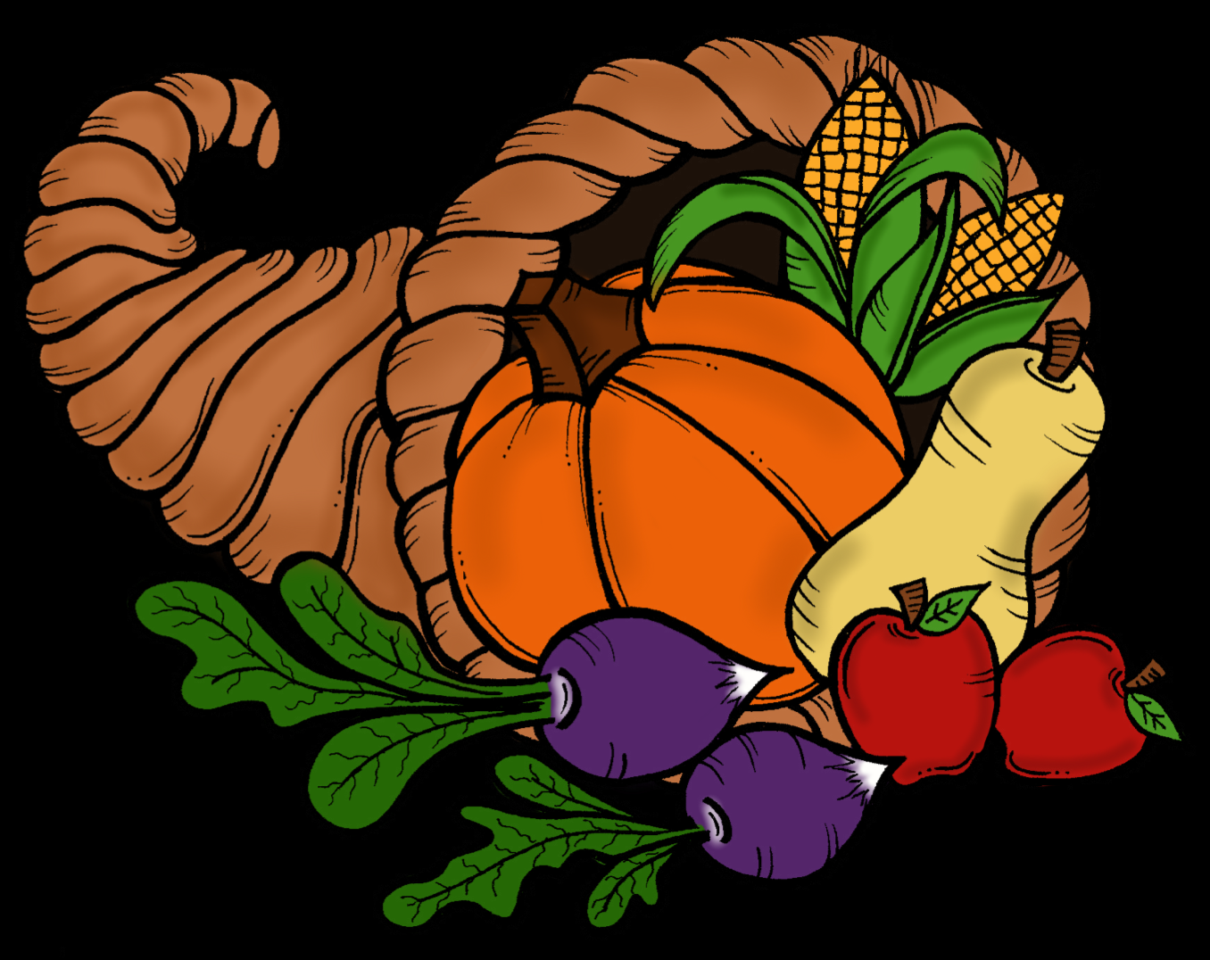

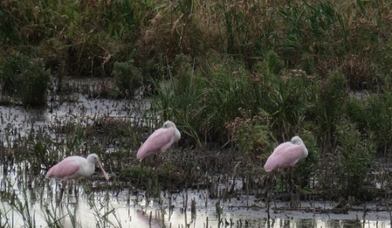
With the whole family fully vaccinated, Jim and I enjoyed separate visits this fall with our son from San Diego and with our daughter and her husband from Tallahassee. In early October Jim and I traveled to the Delaware Bay area for birding, nature, and other interests. At Bombay Hook NWR in Delaware, we were surprised to view roseate spoonbills. The Cape May, NJ area had much to offer, including the Osprey pontoon boat birding tour, Cape May Point State Park (including a monarch tagging demonstration), and, in Stone Harbor, the Wetlands Institute and an impressive art gallery. Our recent walk at Sky Meadows State Park was brightened by autumn color. We’ll spend the holidays here quietly by ourselves.
Best wishes to all for Happy Holidays,
Dottie Joslin

The AAUW Diversity Statement
In principle and in practice, AAUW values and seeks an inclusive membership, workforce, leadership team, and board of directors. There shall be no barriers to full participation in this organization on the basis of age, disability, ethnicity, gender, gender identity, geographical location, national origin, race, religious beliefs, sexual orientation, and socioeconomic status.

Night Owls is Thriving!

A bright spot for the branch is the Night Owls book group. We’ve been reading forever, it seems, and fully enjoy talking about what we read. Once we went virtual, the original evening book group drew in a number of book lovers from the afternoon lit group. The current gatherings attract between six and ten members each month for an online discussion of books—primarily fiction—that are agreed upon for each September to July year. Paulette Miller keeps us organized and makes sure each gathering has a discussion leader. That person does some extra work to provide information about the author’s biography and to keep the discussion lively by raising issues that are important to the book and help us understand it.

We welcome new members for any or all of our discussions. Just let Paulette know if you are interested in attending, and she will make sure you receive the link to the Zoom meeting.

Jan Humphrey

Night Owls 2021-22 Schedule

Our Night Owls Evening Book Group meets on the second Tuesday of the month via Zoom at 7:00 pm. New participants are always welcome. Please contact Paulette Miller to receive the link for each meeting.

Month Book
November 9, 2021 – Anxious People by F. Backman
December 14, 2021 – The Book Woman of Troublesome Creek by Kim M. Richardson
January 11, 2022 – The Four Winds by Kristin Hannah
February 8, 2022 – Stoner by John Williams
March 8, 2022 – The Overdue Life of Amy Byler by Kelly Harms
April 12, 2022 – When All is Said by Anne Griffin
May 10, 2022– Counting by 7’s by Holly Goldberg Sloan
June 14, 2022 - Planning

Calendar
November 17, Wednesday, Celebrating 140 Years of AAUW! 4 p.m. on Zoom
November 21, LWVFA: Fairfax Registrar discusses Voting Rights and our Recent Election, 2 p.m. on Zoom
December 10, Thursday, U.N. International Human Rights Day and Jane Addams Day
December 14, Tuesday, Night Owls, 7 p.m. on Zoom
January 1, 2022, Saturday, Happy New Year!
January 11, Tuesday, Night Owls, 7 p.m. on Zoom
AAUW—FAIRFAX CITY BRANCH
MEMBERSHIP APPLICATION

Membership is open to all graduates who have a two year or a more advanced degree from an accredited institution. AAUW values and seeks a diverse membership.

You can join online at aauw.org. Click on Membership. Scroll down to Branch Member and
click on the +. Click on Find Your Branch. Follow the prompts. Find “VA3042 Fairfax City.” Click on the green Join button and complete the process.

Or, Complete the application below and mail it with your check to the treasurer.
Name: ___________________________________________________________________
Address: _________________________________________________________________
City, State, Zip: ____________________________________________________________
Phone: (H) ____________________ (C) ____________________ (W) _______________
E-Mail: __________________________________________________________________
Degree: _______ College: ___________________________ Field: __________________Year:_____
Degree: _______ College: ___________________________ Field: __________________Year:_____
.DUES: $90 ($62 national, $15 state, $13 branch) for membership through June 30, 2022.

TRANSFERS from National Membership (Member-At-Large), the dues you owe may differ.
If MAL expiration date is in 2021, pay National, state, & branch dues. Dues are $90.
If MAL expiration date is in 2022, pay only State & branch. Dues are $28.
If known: MAL Membership expiration date: ___________ AAUW ID #: ________________

Tax deductible portion of the National dues: For dues of $90, $59 of the national dues are deductible.
Branch membership expires on June 30 in all cases.
Contact: Dottie Joslin, Treasurer

PAYMENT: Make check payable to AAUW—Fairfax City Branch.
Please send this form and your check to the treasurer:

DOTTIE JOSLIN
11110 DEL RIO DR
FAIRFAX, VA 22030-5339

The AAUW Mission Statement
AAUW advances equity for women and girls through research, education, and advocacy.

Fairfax City Branch Website: http://fairfaxcity-va.aauw.net/

Officers:
President: Dianne Blais

Secretary: Anita Light

Treasurer: Dottie Joslin

AAUW Funds and Scholarship:
Paulette Miller

Newsletter Editor:
Dottie Joslin

Communications and Website:
Padmini Chilappagari

Interest Group Chair:
Night Owls: Paulette Miller

