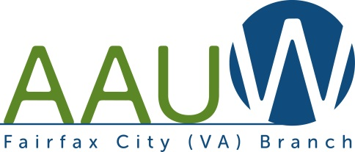

**FOCUS**

Volume 48, No. 3

Spring 2022

**BRANCH MEETING and PARTY**

**SATURDAY, JUNE 4, 2-5 PM**

**Home of Dianne and Gerard Blais**

How long have you waited to visit with your AAUW friends in person? Here’s your opportunity. Come to Dianne Blais’s home on Saturday, June 4 at 2 p.m. – 5 p.m.

There will be a brief business meeting, which will include election of officers for next year. Enjoy conversations with friends as we partake of refreshments.

We plan to spend most of the time outdoors on the deck. In case of rain, we’ll meet instead on *June 11.*

Details will be sent by email at a future time.

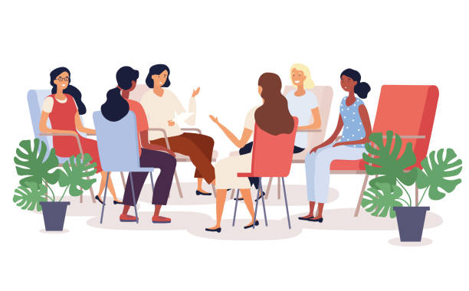

**Election of Fairfax City Branch Officers**

Branch officers are elected for a two-year term begins on July 1. The election of officers will be held at the branch meeting on June 4 at Dianne Blais’s home. Offices to be filled for the next two years are program vice president and secretary. The president (Dianne Blais) and treasurer (Dottie Joslin) have one more year left on their two-year terms.

The candidate for Secretary is Joyce Grimes.

Joyce has been an active member of the Fairfax City Branch since she joined in 2013. She participates in Night Owls, was a member of the Silent Auction team for years, and has contributed to the branch in many other ways.

There is no candidate for Program Vice President.

Would you like to join the branch’s leadership team? In addition to program, vacant positions include the Diversity, Equity and Inclusion liaison to AAUW-VA, membership, and public policy. Let a board member know of your interest. Positions can be shared.

**AAUW of Virginia Public Policy**

The AAUW of Virginia Co-Vice Presidents for Public Policy, Denise Murden and Susan Burk, advocated diligently for our public policy priorities during the 2022 session of the General Assembly. This year AAUW-VA partnered with the Virginia Interfaith Center for Public Policy, a non-partisan advocacy network, which leads the Virginians for Paid Sick Leave coalition. Working with other organizations increased the visibility of AAUW-VA.

The informative AAUW-VA post-General Assembly legislative wrap-up on Zoom featured guest speaker Kim Bobo, Executive Director of the Virginia Interfaith Center for Public Policy (VICPP). Here is where priority issues stood at the end of the General Assembly session.

Paid Sick Days. The Coalition of Virginians for Paid Sick Leave fought for two bills, which passed the Senate. Unfortunately, they died in a sub-committee of the House Energy and Commerce Committee.

Paid Family and Medical Leave. The bills were continued to next year in the Senate.

Ban on salary history of prospective employees. The bill passed the Senate but was tabled in the House.

Bill for a constitutional amendment to automatically restore the voting rights of “returning citizens.” This bill did not pass. Passage for a second time in consecutive years is required to permit it to move to the voters, who must approve any Amendment to the Virginia Constitution. “Returning citizens” includes felons who served their time and citizens released from guardianship.

Public Education Funding. The Senate and House bills differed in the amounts of funding to provide for teacher salary increases and other education spending. These issues were not resolved prior to the budget session. Although AAUW-VA is not a member of *Fund Our Schools,* we depended on their information and advocated through their website.

Increased funding for Affordable Housing through the Housing Trust Fund. The Senate bill provides more money than the House version.

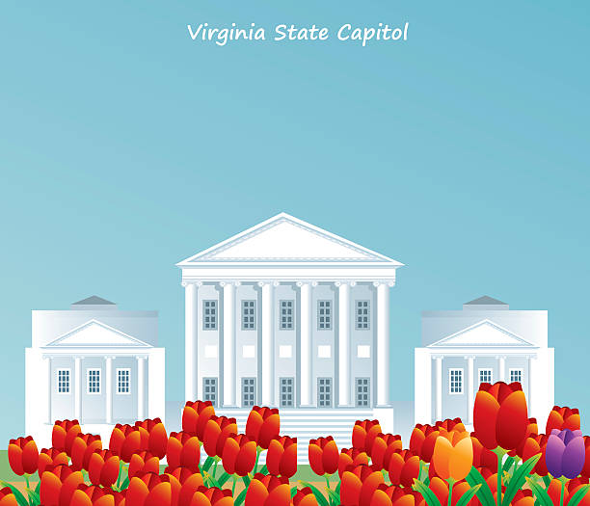

**AAUW National Election: VOTE on Directors and Bylaws Proposals**

Elect members to the national AAUW Board of Directors (4 nominees for 4 positions) and weigh in on changes to the bylaws that would streamline the nominations process and ballot administration.

**Your vote is important:** *At least 5 percent of the votes entitled to be cast must be cast to reach quorum, which is required for the election to be valid.*

To learn more and to vote, search your Inbox for your email from Shannon Wolfe, AAUW, dated April 6. Subject line: *Vote now to Shape AAUW’s Future*. A link to the National Election page and a link to your individual ballot are in the email. Voting closes May 16.

**Join us via Zoom for the 2022 AAUW-VA Annual Business Meeting!**

AAUW of Virginia members are invited to attend the AAUW of Virginia Annual Business Meeting, Part 2 of the State Conference, which will be held via Zoom webinar on April 30 at 1:00 **p.m.** The meeting is scheduled to end at 3:45 p.m.  **You must register in advance for the webinar and to receive the login information.** There is no meeting registration fee.

At our Business Meeting, we will be awarding the prestigious 2022 AAUW Woman of Achievement Award to Virginia State Delegate Eileen Filler-Corn for her outstanding civic contributions, excellent leadership skills, and contributions to the advancement of women. You will hear about the accomplishments of your AAUW-VA Board members as well as the state proposed Public Policy Priorities and amendments to the AAUW-VA Bylaws to be voted on in May. This event also will allow you the opportunity to meet this year’s candidates for elected positions.

To attend, you must [REGISTER](https://aauw.us7.list-manage.com/track/click?u=4cda310c25931a000dcc64cfa&id=6ab485af70&e=996d2a6a8b) in advance for this webinar.

After registering, you will receive a confirmation email with the subject “2022 AAUW of Virginia Annual Business Meeting” with the Zoom log-in information. The Business Meeting Program Book link will be made available via email with the subject "AAUW-VA Business Meeting Program Book" and on the AAUW-VA Conference webpage one week before the meeting.

The AAUW of Virginia Board members look forward to your attending the Business Meeting.

Suzanne Rothwell

AAUW-VA Co-President



**Online Voting for AAUW of Virginia’s One Member/One Vote Election**

This year, you will vote online for candidates for five state offices, a bylaws amendment, and the 2022-2024 AAUW-VA public policy priorities. On April 30, 2022, at the virtual Annual Business Meeting, Part 2 of the State Conference, you will have the opportunity to discuss and amend the bylaws amendment and the proposed public policy priorities. If there are any changes to the information in the *Voter* Guide, we will notify you and post information on the state website.

The *Voter Guide* begins on page 9 of the AAUW-VA Winter-Spring 2022 *Vision:*

<https://aauw-va.aauw.net/files/2022/02/Final2_Vision-WS-2022_print-file-compressed.pdf>

*Voting will begin May 6 and end May 29.* **Please vote!** We need a quorum of 7% of the membership.

WATCH FOR YOUR VOTING INSTRUCTIONS IN EMAILS SENT BETWEEN APRIL AND MAY 2022.

|  |  |  |  |  |
| --- | --- | --- | --- | --- |
| |  |  | | --- | --- | |  |  | |  |  |   AAUW Reston Herndon, NCNW Reston Dulles, LWV Fairfax,  Fairfax County Commission on Women    **UN CEDAW**    “Convention on the Elimination of All Forms of Discrimination Against Women”  A treaty considered to be an international “Bill of Rights” for women.    Fairfax County Board of Supervisors approved a CEDAW Resolution in March!  Learn what CEDAW is and what will it do for protecting women’s fundamental human rights in Fairfax County.  What is the US Policy and what countries have signed and ratified CEDAW?  What can we do to support this resolution?  Working Group for CEDAW representative’s Jill Follows, League of Women Voters Fairfax, and Judi Polizzotti, AAUW Reston Herndon, will answer these questions and more.    Join our discussion    Tuesday, April 26, 7:00 p.m., virtual via Zoom.  Please RSVP to [judithpolizzotti@gmail.com](mailto:judithpolizzotti@gmail.com)  Zoom link will be forwarded with the RSVP |



**AAUW Webinar: *Social Justice: Creating Change***

Thursday, May 26, 2022, at 7 p.m. ET

Social justice is at the core of what AAUW does every day. Whether at the national, state or local level, AAUW staff, volunteers and members work hard to build a more equitable world. What does it mean to support social justice, and how is that different (or the same) as racial justice and economic justice? Please save the date for a discussion of these critical issues.

**Two-Minute Activist**

Send emails and texts to your legislators to fight for equal pay, family leave, stopping sexual harassment, equality in education and more. Sign up to get regular alerts to be able to take timely action:

<https://www.aauw.org/act/two-minute-activist/>

**AAUW Community Hub**

AAUW is in the process of a database conversion. Some of you may have used AAUW’s Member Services Database (MSD), which is no longer accessible. The new AAUW [Community Hub](https://my.aauw.org/NC__Login) is every member’s personal portal into AAUW. It allows people to self-manage their membership, donations, contact details and personal preferences.

The Community Hub joins several systems that did not previously “talk to” each other. Moving forward, this integration will help AAUW operate more efficiently, collaborate more effectively, and track meaningful information for all the individuals and organizations we engage.

To access the Community Hub, click on the link above, or go to <https://my.aauw.org> On the Welcome page, the first time you use Community Hub, you can create a new account or *reset* *your password* to login. (Click on the appropriate question below the password box.) Enter a *new* *password*. You will be redirected to the Personal Snapshot page. If you receive an error message, like “You are not a member,” contact [connect@aauw.org](mailto:connect@aauw.org).

The menu on the left of the Personal Snapshot page gives access to various features. Please go to My Contact Information and verify or edit your email address and other contact information.

If you had a password previously to use for the MSD and other member services, remember it. You can still use it at AAUW’s general website, [www.aauw.org](http://www.aauw.org), for member and leader resources. Use your new password at <https://my.aauw.org> for the Community Hub.

You do not have to create an account on the Community Hub, which is still a work in progress. Later, you will be able to renew your membership online through the Community Hub, but you are welcome to renew by check. Dues will be $95.

***Late in May, you’ll receive instructions by email about how to renew your membership.***

**Membership**

**Member Update**

Padmini Chilappagari: 23872 Welch Ridge Pl., Aldie, VA 20105

**New Member**

Josephine DiCalogero, 9712 Doulton Ct., Fairfax, VA 22032

cdicalogero@verizon.net

**Earth Day Event: *Let’s Planet Together***

**The Nature Conservancy**

This Earth Day, let’s shift the conversation about our planet from dire to doable. Let’s Planet Together!

Join us on April 22 from 5 - 6 p.m. for an entertaining and inspiring hybrid in-person and online event! You’ll hear from community leaders and scientists who are tracking moose migrations, restoring coral reefs, conserving the Amazon and even brewing sustainable beer!

Plus, special guest appearances from Prince EA, Rosario Dawson, Meryl Streep, Coyote Peterson and Rainn Wilson, and a musical performance from Aloe Blacc!

[Learn More About the Event and Sign Up Today](https://natureconservancy.brandlive.com/planettogether/en?en_txn8=NewSch.WJEMSA2204NPNZNZZE01Z00-ZZZZZ-ST00&lu=189cecd9-ed62-4360-ab1a-5be10bfa34cd&en_txn1=e.ch_va.eg.x.gpn.0406.n.sas.unv&utm_source=e.br.eg.earth22.nn0406)



**School-to-Prison Pipeline**

Mt. Vernon AAUW and Alexandria AAUW branches invite all AAUW members to attend our Panel Discussion on Zoom, Saturday, April 23, at 10:30 A.M.

This program will educate us on the issue of criminalizing student behavior in school.  We do not take a stand on the issue of having police officers in schools but want to educate ourselves on the issues involved.

For more information and to register, go to: <https://librarycalendar.fairfaxcounty.gov/event/8734182>

**Night Owls is Thriving!**

**Night Owls 2021-22 Schedule**

Our Night Owls Evening Book Group usually meets on the second Tuesday of the month via Zoom at 7:00 p.m.  We welcome new participants for any or all of our discussions.

******Our next meeting will be on May 10 for a discussion of ***Counting by 7’s*** by Holly Goldberg Sloan, led by Jean Arnold. Please contact Paulette Miller, psmiller10847 at verizon.net or 703-250-0876, to receive the link for the May meeting or to verify the in-person June meeting.

**Month                    Book**

May 10,– ***Counting by 7’s*** by Holly Goldberg Sloan

June 13, **MONDAY, Noon**, – Planning, Home of Kelly Espy

**The Jüdische Kulturbund Project: Bullets to Books**

Over a decade ago, our branch hosted a presentation by Gail Prensky, creator, executive producer, and director of *The Jüdische Kulturbund Project*. The presentation included her short video about the Jüdische Kulturbund, a Nazi-sanctioned Jewish cultural association, 1933-1941, in which Jewish musicians and artists performed in theatres in 42 cities across Germany for Jewish audiences. The Jüdische Kulturbund was established after the Nazis banned Jews from the professions and arts in 1933.

Now, “*The Jüdische Kulturbund Project* embraces connections with people of all ages who live around the world, bringing a collective voice for peace and freedom through creative expression. As we are inspired by these voices, we encourage everyone to join us in recognizing the power of music and art as vehicles for healing and resilience.”

Over the last few years Gail has collaborated with Jok Abraham Thon through their *Bullets to Books* initiative to support his Promised Land School, a top-quality secondary school in Juba, South Sudan. During South Sudan’s recent civil war, students’ opportunities to attain an education were limited. Jok’s goal is to redirect eager young people from strife to education.

To view a short video about the *Bullets to Books* initiative, go to <https://www.judischekulturbund.com/bullets-to-books-the-feature-documentary-film/>

On May 1 at 10 a.m. see the online conversation with DC-based artist Phoebe B. and Jok Abraham Thon about art, cultural exchange, and the watercolor Phoebe made in support of the Promised Land Secondary School. An invitation to the conversation, as well as information on other initiatives of *The Jüdische Kulturbund Project,* is at [The Jüdische Kulturbund Project Newsletter-Winter 2022 (mailchi.mp](https://mailchi.mp/105984341ef6/the-jdische-kulturbund-project-newsletter-winter-2022?e=c7166ff091))

**Calendar**

**April 22**, Friday, 5 – 6 p.m. Earth Day: The Nature Conservancy’s *Let’s Planet Together,* Zoom

**April 23**, Saturday, 10:30 a.m. School-to-Prison Pipeline. Zoom. Registration required. <https://librarycalendar.fairfaxcounty.gov/event/8734182>

**April 26,** Tuesday, 7 p.m., CEDAW virtual discussion. RSVP to [**j**udithpolizzotti@gmail.com](mailto:judithpolizzotti@gmail.com)for Zoom link.

**April 28,** Thursday, 7 p.m. Fairfax City Branch board meeting on Zoom.

**April 29**, Friday, 9 a.m. – 9 p.m.; **April 30**, Saturday, 9 a.m. – 4 p.m**. Falls Church Area Branch Book Sale,**  Falls Church Community Center, 223 Little Falls Street, Falls Church, just off Route 7

<https://fallschurcharea-va.aauw.net/booksale/>

**April 30,** Saturday,1:00 p.m**.** AAUW of Virginia Annual Business Meeting, Zoom, [Register here](https://aauw.us7.list-manage.com/track/click?u=4cda310c25931a000dcc64cfa&id=33500cd97c&e=996d2a6a8b)

**May 1**, Monday, 10 a.m. The Jüdische Kulturbund Project, *Bullets to Books* Zoom conversation. Registration: [The Jüdische Kulturbund Project Newsletter-Winter 2022 (mailchi.mp](https://mailchi.mp/105984341ef6/the-jdische-kulturbund-project-newsletter-winter-2022?e=c7166ff091))

**May 6,** Friday, AAUW-VA election, online voting opens.

**May 10,** Tuesday,7 p.m**.** Night Owls, Zoom.

**May 16,** Monday, 5 p.m. Voting closes for AAUW National Election

**May 26,** Thursday, 7 p.m. AAUW webinar, *Social Justice: Creating Change.*

**May 29,** Sunday, 11:45 p.m. AAUW-VA online voting closes.

**June 4,** Saturday, 2 – 5 p.m. **BRANCH MEETING AND PARTY**, Home of Dianne and Gerard Blais

**June 13,** Monday, Noon.Night Owls, Planning meeting, Home of Kelly Espy

**The AAUW Diversity Statement**

In principle and in practice, AAUW values and seeks an inclusive membership, workforce, leadership team, and board of directors. There shall be no barriers to full participation in this organization on the basis of age, disability, ethnicity, gender, gender identity, geographical location, national origin, race**,** religious beliefs, sexual orientation, and socioeconomic status.

**AAUW—FAIRFAX CITY BRANCH**

**MEMBERSHIP APPLICATION**

Membership is open to all graduates who have a two year or a more advanced degree from an accredited institution. AAUW values and seeks a diverse membership.

Please complete the application below and mail it with your check to the treasurer.

Name: ___________________________________________________________________

Address: _________________________________________________________________

City, State, Zip: ____________________________________________________________

Phone: (H) ____________________ (C) ____________________ (W) _______________

E-Mail: __________________________________________________________________

Degree: _______ College: ___________________________ Field: __________________Year:_____

Degree: _______ College: ___________________________ Field: __________________Year:_____

DUES: $95 ($67 national, $15 state, $13 branch) for membership through June 30, 2023.

TRANSFERS from National Membership (Member-At-Large), the dues you owe may differ.

If MAL expiration date is in 2022, pay National, state, & branch dues. Dues are $95.

If MAL expiration date is in 2023, pay only State & branch. Dues are $28.

If known: MAL Membership expiration date: ___________ AAUW ID #: ________________

Tax deductible portions of the National dues: For dues of $95, $64 of the national dues are deductible.

Contact: Dottie Joslin, Treasurer, [j.joslin3@verizon.net](mailto:j.joslin3@verizon.net); 703-591-9035.

PAYMENT: Make check payable to *AAUW—Fairfax City Branch*.

Please send this form and your check to the treasurer:

DOTTIE JOSLIN

11110 DEL RIO DR

FAIRFAX, VA 22030-5339



**The AAUW Mission Statement**

*AAUW advances equity for women and girls through research, education, and advocacy.*

**Fairfax City Branch Website:** http://fairfaxcity-va.aauw.net/

**Officers:**

President: Dianne Blais

Dianneblais at aol.com

Secretary: Anita Light

[anita.light95 at gmail.com](mailto:anita.light95@gmail.com)

Treasurer: Dottie Joslin

[j.joslin3 at verizon.net](mailto:j.joslin3@verizon.net)

AAUW Funds and Scholarship:

Paulette Miller

[psmiller10847 at verizon.net](mailto:psmiller10847@verizon.net)

Newsletter Editor:

Dottie Joslin

[j.joslin3 at verizon.net](mailto:j.joslin3@verizon.net)

Communications and Website:

Padmini Chilappagari

[padmini89 at gmail.com](mailto:padmini89@gmail.com)

**Interest Group Chair:**

Night Owls: Paulette Miller

[psmiller10847 at verizon.net](mailto:psmiller10847@verizon.net)

Note: For security, the @ in email addresses was replaced with “ at ”. To contact the members, reconstruct a usable address by deleting “ at ” and inserting @.

